We Moved!!

Bartolini’s 2.0
3844 West 147th Street Midlothian, Illinois 60445
708-396-2333

Parking is available….
-In Our Main Lot on Springfield Ave
Enter off of 147th St and exit
onto Springfield North or South.
The Lot is One Way going North off 147th St
Please do not Park along Springfield Ave
or the Parkway adjacent to Our Lot.
-In Our Back Lot, behind the Building off Avers
-Street Parking along 147th Street
-Metra Lot Parking is No Charge
after 11:00 Am Weekdays
& Complimentary on Weekends
-Please refrain from Parking in other Business’s Lots
Thank You
The Bartolini Brothers!

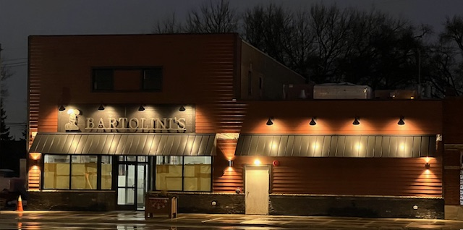
Parking Map
It’s not the Prettiest Map, but should help.

Any questions, give us a call.
708-396-2333
